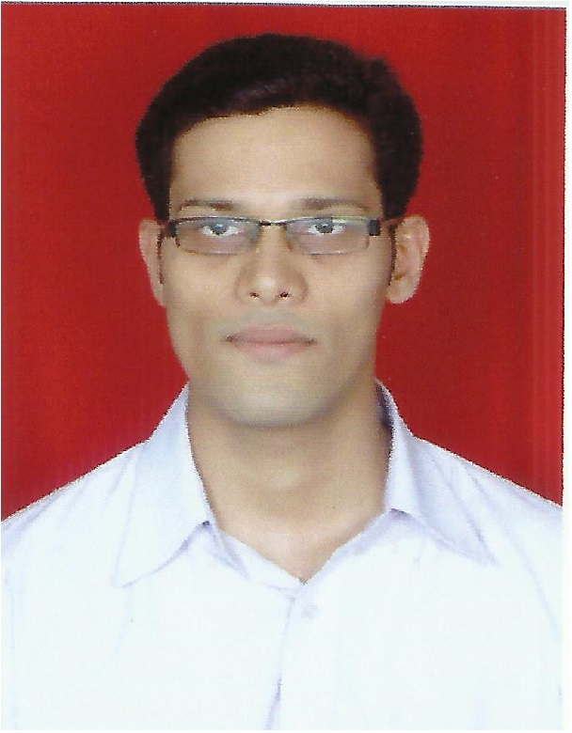
SANKET NAMDEV MAHADIK.

3/12, Rajesh Chawl, St. Xavier Colony
Kanjurmarg (East), Mumbai- 400042,
Maharashtra, India.

Mobile No.:-09987863046. E mail: - sanket.6047@gmail.com

PERSONAL STATEMENT:

I’m an experienced Electrical Engineer who has supervised and participated in LV electrical design (Lighting & Power Distribution), commissioning and related works along with power quality analysis.

I’m looking to bring my reputation for taking technical, complex projects from inception to completion.

SELECTED ACCOMPLISHMENTS:

- Replacement of regular 36 watt tubes with LED tubes to grow tissue cultured sugar cane plants for energy conservation.
- Street Light Design at Vasantdada Sugar Institute Campus, Pune.
- Supervision on renovation work (Electrical) of labs and four floor hostel building.
- Inspection of different LT panels.
- Fault rectification at sugar factories with seniors.

ACHIVEMENTS:

- Energy Audit at 100/22 KV substation at college level.
- Presented, ‘Grid Free Electric Power from Biogas for Rural Community Service’, in State Level Student’s Conference.
- Kho-Kho at school and university level.
- Basic civil defense course.

EMPLOYMENT DETAILS:

- VASANTDADA SUGAR INSTITUTE, PUNE.
Duration: From 20THDECEMBER 2012 to 19THDECEMBER 2014.
Department: Sugar Engineering.
Position: Junior Electrical Engineer.
Description: Distribution and planning of work, Electrical project execution and supervision.
- Inspection of panels (MCC) as consultant of sugar factories,
- Checking of total panel dimensions.
- Material checking as per BOM
- HV Test & Megger Test of panels.

- Maintenance’s job responsibilities:-
- Planning of manpower for preventive maintenance as per schedule.
- Planning of emergency breakdown.
- Follow up of indented material with Purchase Dept.
- Checking of store stock and to look after smooth store software running.
- Meeting with M.S.E.D.C.L officers as and when required.
- Execution of modification work suggested by superiors.
- Estimation and execution of work mentioned in Capital Budget.
- Preparation of Idea, BSNL bills and submitting to the Accounts dept. and also, checking of diesel stock report and energy bills.

- Renovation Work’s job responsibilities:
- Checking and preparing of measurement sheet.
- Supervision on progress of work.
- Selection of required light fittings and other material with Architect.
- Co-ordinate with Architect, consultant and contractors.

PROJECTS Handled:
- New Hostel Building, Winery LAB, Microbiology LAB, VIP Bunglows, VIP Offices:
- Work execution as per BOM & Drawings.
- Checking of illumination level as per suggestions of architect.
- Light fitting, Exhaust Fan, AC selection with architect.
- Sizing of exhaust fan, AC, with the help of seniors.
- Measurements and billing including fire system.
- Auditorium:
- Work execution as per BOM & Drawings.
- Checking of illumination level as per suggestions of architect & consultant.
- Light fitting, exhaust fan selection with architect.
- Supervision on Installation of 52 HP (Outdoor) VRV (Daikin) HVAC system.

- DIPILEC ENTERPRISES, MUMBAI.
Duration: From 4THJUNE 2015 to 23RDOCTOBER 2015.
Department: Electrical
Position: Electrical Engineer.
Description: Sizing of transformer, cables, switchgears, feeders and basic design of illumination level and wiring, street light, project execution and supervision at Junior Level.

- SYSCON ENERGY CONSERVATION SOLUTIONS PVT. LTD., PUNE
Duration: From 2ND NOVEMBER 2015 to 8TH FEBRUARY 2017
Department: Power Quality Analysis
Position: Senior Engineer (Projects).
Description: To find potential for Power Quality Audit, Energy Audit and Thermography in market and generate leads, carry out Power Quality Audit, Thermography Analysis, Assist in Energy Audit, to understand the recommendations and solutions suggested by seniors, presentation to customer.

- COMPUTECHNICS, MUMBAI (BRANCH OF SYSCON ENERGY, PUNE)
Duration: From 9TH FEBRUARY 2017 to 29th JULY 2017
Department: Power Quality Analysis
Position: Senior Engineer (Projects).
Description: To find potential for Power Quality Audit, Energy Audit and Thermography in market and generate leads, carry out Power Quality Audit, Thermography Analysis, Assist in Energy Audit, to understand the recommendations and solutions suggested by seniors, presentation to customer.

- MAGNA INFOTECH, CLIENT: PHILIPS LIGHTING INDIA PVT LTD
Duration: From 27TH SEPTEMBER 2017 to TILL DATE
Department: Customer Satisfaction Department
Position: Service Support Engineer.
Description: To resolve issues related to customer. To manage service provider to resolve complaints from customer

INDUSTRIAL TRAINING:

- ‘LARSEN AND TOUBRO LTD.’
Duration: From 17THDECEMBER 2007 to 16THDECEMBER 2008.
Department: EBG-Switchgear Test Engineering
Position: In-plant Trainee.
Project Title: Commissioning Of Test Benches.
Description: Maintenance & installation of test benches, testing of test-
benches

KEY SKILLS:

Technical Skills-
- Proficiency in working with MS Excel, MS Word, MS Power point

Personal Skills-
- Committed team member and a strong believer in team effort, Strong learning and organizing skills matched with the ability to manage stress, time and people.

CERTIFICATES:

- Certified course in Allen Bradley SLC 5/04 PLC programming and application from Advanced Training Institute (ATI), Mumbai.
- Two days training course in Biogas (ARTI Compact Biogas) from Appropriate Rural Technology Institute, (ARTI), Phaltan.

EDUCATION:

Examination | University | Percentage | Class
B.Tech.  (Electrical Engineering.) | Dr. Babasaheb Ambedkar Technological University, Lonere, Raigad.  (2009-2012) | 7.30 (66.36%) | First Class
Licentiate Diploma L.E.E (Electrical Engineering.) | Veermata Jijabai Technological Institute, Matunga, Mumbai.(2005-2009) Mumbai. | 83.67% | Distinction
H.S.C. | Ramniranjan Jhunjhunwala College, Ghatkopar, Mumbai.(2005) | 45.33% | Pass Class
S.S.C | Mumbai.  I.E.S Secondary School, Bhandup, Mumbai.(2003) | 82.26% | Distinction

PROJECT PROFILE:

- Distributed Power Generation From Wind, Solar and Biomass (B. Tech):-
Aim of this project is to integrate three renewable energy resources to overcome power related issues especially for rural areas.
- Decibel Meter(L.E.E) :-
Aim of this project is to measure the noise level in particular area and according to that certain level or limit of noise is decided for that area to reduce noise pollution.

SEMINAR TOPIC (B. TECH):

- Energy efficient Photovoltaic (PV) Inverter:-
Aim of this seminar is to make optimum use of PV inverter to overcome power failure problem.

PERSONAL PROFILE:

- Date of Birth : 18th May 1987.
- Nationality : Indian.
- Gender : Male.
- Marital Status : Single
- Languages Known : Marathi, English, and Hindi.
- Hobbies : Playing Cricket, Kho-Kho.

I hereby declare that above information is true to my knowledge & belief.

Date:

Place: Sanket N. Mahadik.

